Spring’ 24

**M Bastle Ullah - 14209**

**Tahreem Akram - 14115**

**FollowMe Trolley**



**ABSTRACT:**

The Human-Following Trolley project aims to develop an autonomous, intelligent trolley that can follow a designated individual, enhancing the ease of transporting goods in various environments such as shopping malls, airports and hospitals. The system employs an ESP-32 Cam for the real-time image and video capture, alongside an ESP-32 module for processing and control. By leveraging advanced computer vision algorithms, the trolley can accurately detect and track a specific person, adjusting its movement to maintain a safe and consistent following distance. The project demonstrates a cost-effective and efficient solution by utilizing readily available components, making it applicable for both personal and commercial uses. The resulting trolley not only reduces the physical effort required by individuals but also enhances operational efficiency across various settings.

**INTRODUCTION:**

With the rapid advancement of technology, the development of autonomous systems has gained significant momentum, offering innovative solutions for everyday tasks. One such innovation is the Human-Following Trolley, designed to provide hands-free assistance in transporting goods. This project focuses on creating an intelligent trolley that autonomously follows a designated individual, through an RFID tag, utilizing the capabilities of the ESP-32 CAM and ESP-32 module.

Firstly, an RFID tag is placed on the person that unlocks the trolley. The human-following trolley then enables the computer vision to capture the real-time images and videos, enabling it to detect and track a specific person. The ESP-32 CAM captures the visual data, while the ESP-32 module processes this information to control trolley’s movements, ensuring that it maintains a safe and consistent distance from the user. This integration of hardware and software creates a seamless and responsive system capable of navigating various environments such as airports, shopping malls and hospitals.

**HARDWARE COMPONENTS:**

1. ESP-32 Dev Module
2. ESP-32 CAM
3. MFRC522 RFID RC522
4. One Channel Relay
5. DC gear motors
6. Ultrasonic sensors
7. 4x18650 lithium batteries
8. 4x lithium battery holders
9. L298n motor driver (as a voltage regulator)

**SOFTWARE USED:**

1. Arduino IDE
2. Python

**DESCRIPTION:**

* **ESP32:**

ESP32 DEV module is a versatile microcontroller board featuring the powerful ESP-32 chip, which offers dual-core processing, built-in Wi-Fi and Bluetooth capabilities. With 38 GPIO pins, it provides ample connectivity options for various sensors, actuators, and peripherals, making it suitable for complex IoT projects. The module supports a wide range of programming environments, including Arduino IDE and MicroPython, enhancing its accessibility and ease of use for developers. Its robust performance, extensive connectivity, and flexibility make it an excellent choice for a variety of embedded applications.

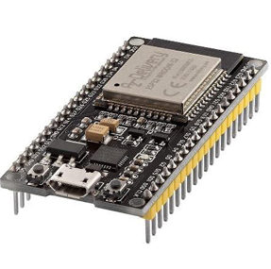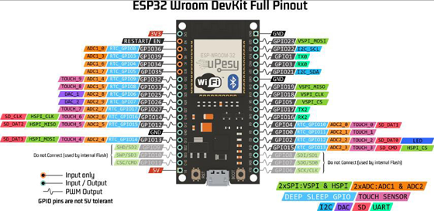

* **ESP 32 CAM:**

The ESP-32 CAM is a compact, powerful module equipped with a 2MP camera, designed for capturing high-resolution images and videos. It features the ESP-32 microcontroller, known for its robust processing power, integrated Wi-Fi, and Bluetooth capabilities. This module supports various applications, including face detection and recognition, making it ideal for projects requiring real-time image processing and wireless connectivity. Its cost-effectiveness and versatility make it a popular choice for IoT and AI-driven projects.

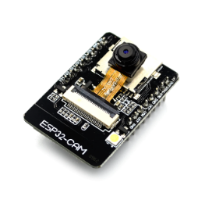 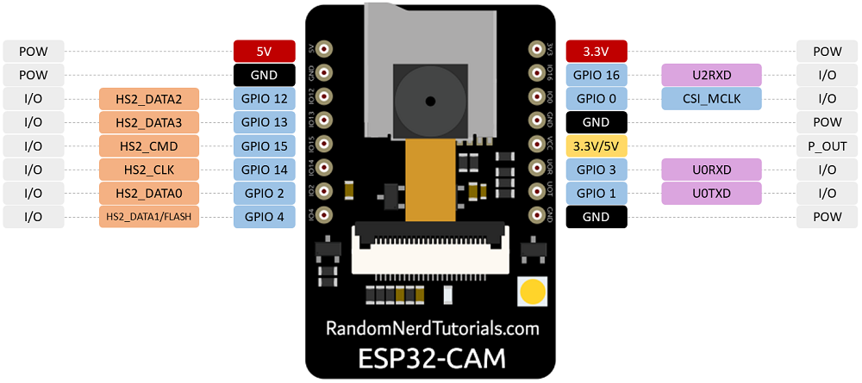

* **MFRC522 RFID RC522:**

The MFRC522 RFID RC522 is a popular RFID reader/writer module used for reading and writing data to RFID tags. Operating at a frequency of 13.56 MHz, it supports various RFID protocols, including ISO/IEC 14443 A/MIFARE. The module features a compact design with an SPI interface, making it easy to integrate with microcontrollers like the Arduino and ESP-32. Its affordability and reliability make it a common choice for access control, identification systems, and various other RFID-based projects.

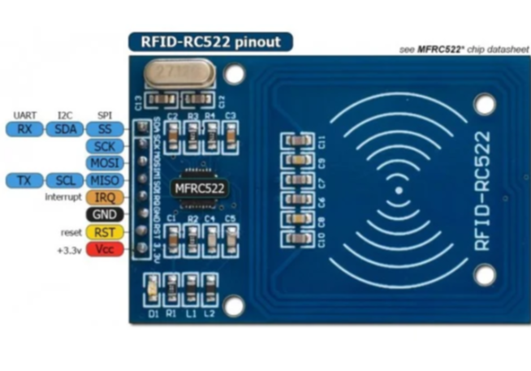

* **RELAY MODULE:**

A power relay module is an electrical switch that is operated by an electromagnet. The relay module is a convenient board which can be used to control high voltage, high current loads such as motors, solenoid valves, lamps and AC loads. It is designed to interface with microcontrollers such as Arduino, PICs, ESPs, etc.

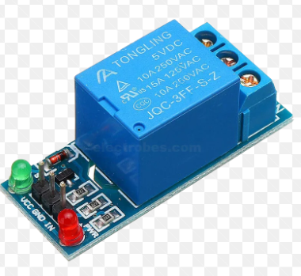 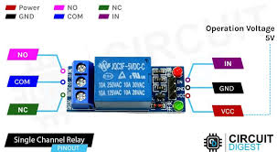

* **DC GEAR MOTORS:**

A DC gear motor combines a direct current (DC) motor with a gearbox to provide high torque at low speeds, making it ideal for applications requiring precise and powerful movement. The gearbox reduces the motor's speed while increasing its torque, allowing for better control in robotics, automated systems, and mechanical projects. These motors are available in various sizes and gear ratios, providing flexibility for different design requirements. Their reliability and efficiency make them a popular choice for driving wheels, conveyor belts, and other mechanical components.

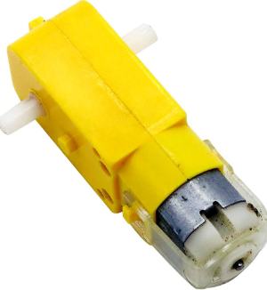

* **ULTRASONIC SENSORS:**

Ultrasonic sensors use sound waves to measure distances to objects by emitting high-frequency sound pulses and detecting their echoes. They are commonly used for obstacle detection, distance measurement, and level sensing in various applications such as robotics, automotive systems, and industrial automation. Ultrasonic sensors are valued for their accuracy, reliability, and ability to function in diverse environmental conditions, including in the presence of dust, light, and humidity. Their non-contact nature makes them ideal for measuring distances to both solid and liquid surfaces.

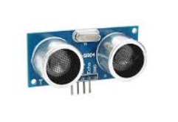 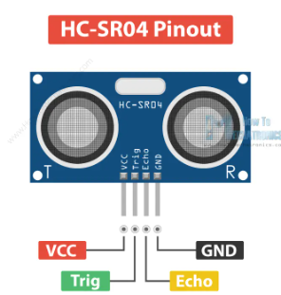

* **LL298N MOTOR DRIVER:**

The L298N motor driver module is a popular dual H-bridge motor driver that can control the speed and direction of two DC motors simultaneously. It can handle high currents up to 2A per channel and voltages up to 46V, making it suitable for a wide range of motor applications. The module is easy to use with microcontrollers like Arduino and Raspberry Pi, providing a convenient solution for driving motors in robotics, automation, and other projects requiring precise motor control. Its built-in protection features, such as thermal shutdown and current limiting, enhance its reliability and safety during operation.

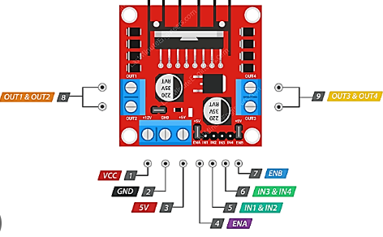

**WORKING:**

**SCHEMATIC DIAGRAM:**

**CIRCUIT DIAGRAM:**

**BLOCK DIAGRAM:**

**FLOWCHART:**

**CODE:**

**FUTURE ENHANCEMENTS:**

**CONCLUSION:**